Defend Resettlement in NH: Oppose NH HB 1706
Submit Public Testimony
Submitting online testimony to a Senate Committee is one of the most effective ways to voice your concern about legislation in New Hampshire. The tally of comments for or against a bill are often cited at hearings.
Submit your comment opposing HB 1706 before the hearing on April 1 at 9:45 AM. You will be asked to take five simple steps:
Step 1: Personal Information
When filling out the contact form, be sure to include your New Hampshire city or town so they can verify that you are a constituent.
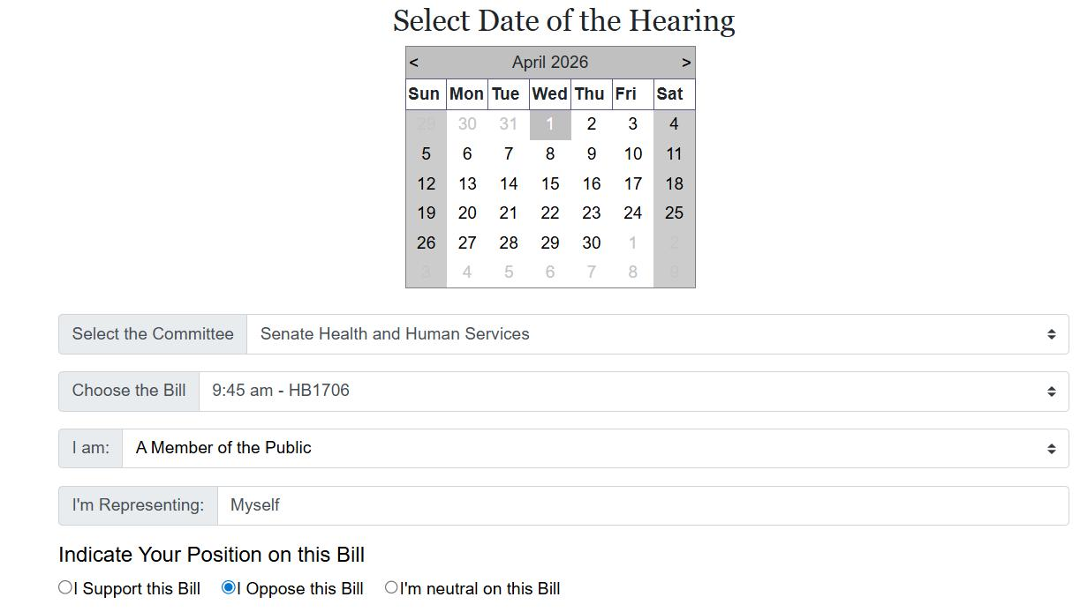
Step 2-3: Date and Bill
Select: Wednesday, April 1 on the calendar.
The Committee is: "Senate Health and Human Services "
The Bill is: 9:45 AM - HB1706
Select: Member of the Public
Representing: Myself
Indicate Your Position: Oppose
Step 4: Final Review
Review your submission, click the box as indicated to confirm, and click “Continue.”
Step 5: Submit Testimony (Optional)
On the final screen there is an option to send your comments to the committee. The link provided will open an email message addressed to the committee members.
The most effective messages are clear and direct, and if relevant, include stories from personal experience.
Here are some talking points on HB 1706:
- This extremist bill would repeal New Hampshire’s refugee resettlement program and prohibit the use of state funds to assist refugees.

- This bill pointlessly targets immigrants who have been extensively vetted and welcomed by our federal government and our state after escaping horrific persecution and violence.
- We want and need these new Americans here. They are friends, neighbors, co-workers and classmates who are contributing to our communities, filling dangerous gaps in our labor force, and strengthening New Hampshire’s economy.
- Far from saving the state any money, this bill could actually cause us to lose federal grants that support workforce development and health programs—all in the name of fear and xenophobia.
- As our state faces a rapidly aging population and shortages in health care and other industries, refugee resettlement is an investment in our demographic and economic security.
- Supporting refugees is also consistent with New Hampshire’s values of compassion, fairness, and opportunity for hard-working families seeking safety.

